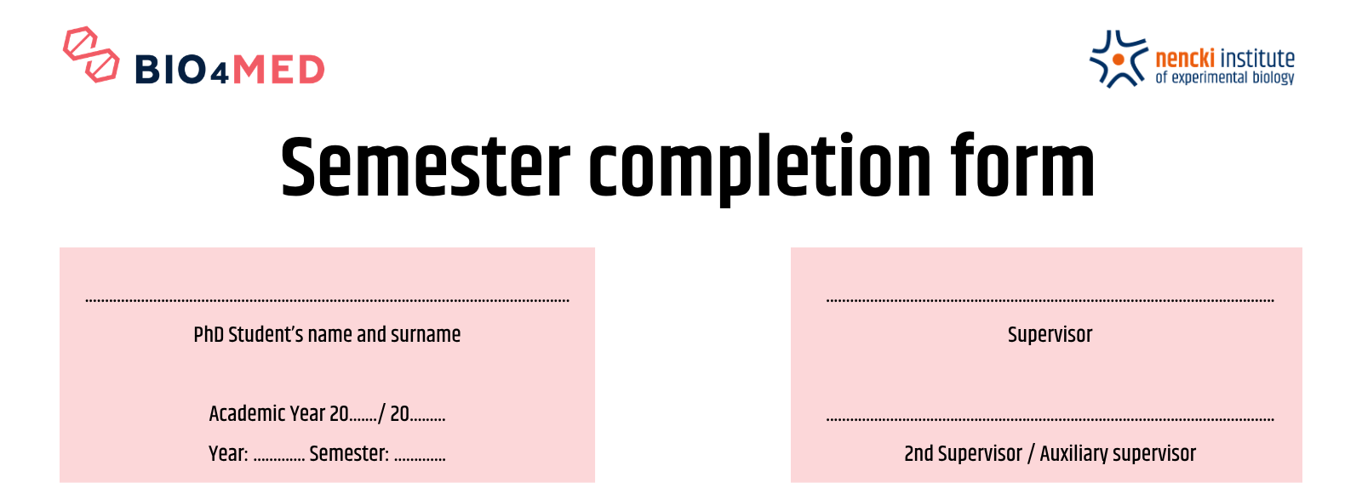

(A) Compulsory classes
Subject which must be obtained during first two years of PhD course – Biochemistry I and II or Neurobiology I and II, Statistics for biologists and Bioethics.
Level 8 of the Polish Qualifications Framework | Subject | Date | Grade / pass / percent | Coordinator’s signature /  PhD Officer’s signature
P8S_WG  P8S_UW  P8S_KK | Biochemistry I
P8S_WG  P8S_UW  P8S_KK | Biochemistry II
P8S_WG  P8S_UW  P8S_KK | Neurobiology I
P8S_WG  P8S_UW  P8S_KK | Neurobiology II
P8S_UW | Statistics  for biologists
P8S_WG2  P8S_KO1  P8S_KO2  P8S_KR1 | Bioethics
P8S_UK | Nencki Institute Seminar
P8S_UU | Training in laboratory
P8S_UK | PhD Student’s Conference
P8S_WK*
P8S_UO**
Grading scale: very good (5); good plus (4+); good (4); pass plus (3+); pass (3); fail (2).
* You should take one of the subject mentioned below or on a similar topic (also at another institution):
- Patenting research results and protecting intellectual property [learning outcomes: P8S_KR, P8S_WK, P8S_KO, P8Z_KP]
- Ethics in scientific research [learning outcomes: P8S_WK, P8S_KK, P8S_KR]
- Research methodology [learning outcomes: P8S_WK, P8S_KK, P8S_KR]
- SPARK webinars [learning outcomes: P8S_WK, P8S_UO]
** You should take one of the subject mentioned below or on a similar topic (also at another institution):
- Preparing grant applications [learning outcomes: P8S_UU, P8S_UO]
- SPARK webinars [learning outcomes: P8S_WK, P8S_UO]

Characterization of the learning outcomes for the qualification
at level 8 of the Polish Qualifications Framework (PQF)
 |  | a person who graduated from doctoral school knows and understands:
KNOWLEDGE | P8S_WG | global achievements, covering theoretical foundations as well as general and selected specific issues that are relevant to scientific disciplines studied at the doctoral school, to the extent that enables revision of existing paradigms,  key developmental trends of disciplines of science in which education at the doctoral school takes place,  scientific research methodology in disciplines represented at the doctoral school,  principles of disseminating results of scientific activity, also in an open access mode
KNOWLEDGE | P8S_WK | fundamental dilemmas of the contemporary civilization,  economic, legal, ethical and other vital conditions related to scientific activity,  basic principles of knowledge transfer to the economic and social sphere as well as those of commercialization of results of scientific activities and know-how related to these results.
 |  | a person who graduated from doctoral school can:
SKILLS | P8S_UW | use knowledge from different fields of science to creatively identify, formulate and innovatively solve complex problems or to perform research tasks such as:  - define the aim and subject of scientific research, form a research hypothesis,  - develop research methods, techniques and tools and use them creatively,  - draw conclusions on the basis of research results,  critically analyze and assess scientific research results, work of experts and other creative activities together with their contribution into knowledge development,  transfer the results of scientific activity to the economic and social sphere,
SKILLS | P8S_UK | communicate on specialist issues on the level that allows active participation in the international scientific community,  share results of scientific activity also in a popular form,  initiate debates,  take part in scientific discourse,  use the English language on at least B2 level, according to the Common European Framework of Reference for Languages (CEFR), to a degree which allows active participation in the international scientific and professional community,
SKILLS | P8S_UO | plan and implement individual and team research projects, also in the international community,
SKILLS | P8S_UU | independently plan and act for their self-development as well as inspire and organize development of others,  plan classes and groups of classes and conduct them with the use of up-to-date methods and tools.
 |  | a person who graduated from the doctoral school is ready to:
SOCIAL COMPETENCIES | P8S_KK | critically assess achievements within a given scientific discipline,  critically evaluate their own contribution to development of a given scientific discipline,  acknowledge the importance of knowledge in solving cognitive and practical problems,
SOCIAL COMPETENCIES | P8S_KO | fulfilling the social obligations of researchers and creators,  initiate actions in the public interests,  think and act in an entrepreneurial manner,
SOCIAL COMPETENCIES | P8S_KR | maintain and develop the ethos of research and creative communities, including:  - conducting independent scientific activity,  - respecting the principle of public ownership of the results of scientific activities, including the principles of intellectual property protection.

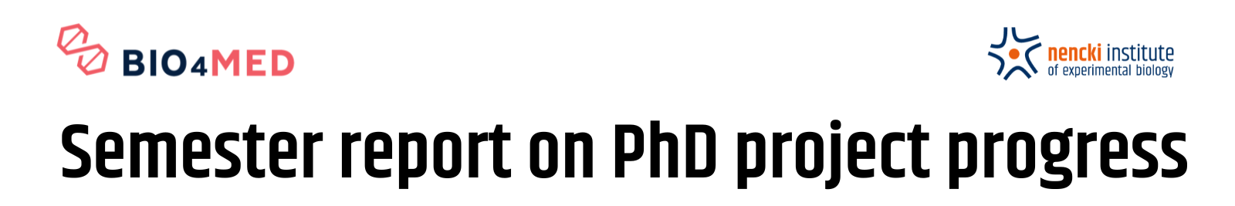

(B) Description of the research conducted
To be filled in by the PhD student
1. Research problem, results previously obtained by the PhD student or within a team, constituting the basis of work executed within the reviewed semester (maximum of 1500 characters).

2. Tasks executed by the PhD student within the last semester, along with main results and conclusions (maximum of 1500 characters).

3. Tasks to be executed by the PhD student within the next semester (maximum of 1500 characters).

I declare that the data provided in this review are correct and true

...............................................
PhD student’s signature

(C) Supervisor's opinion on the completion of the research progress and other scientific activities and achievements by the PhD student during current semester
To be filled in by the supervisor or auxiliary supervisor
Supervisor's opinion:

I assess PhD student’s research progress in the reference semester as:
POSITIVE NEGATIVE

..............................................................................
Supervisor’s or auxiliary supervisor’s signature

(D) Semester/year completion
To be filled in by the Head of Discipline
YES NO CONDITIONAL COMPLETION*

Notice:

………………………… ......................................................
Date Seal and signature

* Head of Discipline gives consent for conditional credit for the academic year and determines the manner and deadline for making up for any deficiencies during the following academic year

